Maud Yorke
English 11000
Professor Carr
10/21/2021

The Outsider Life

Everyone is special in their own way and should not be marginalized because of it. There are always students or people who like to be on their own or, as people will say, they are introverted people. I was one of them and still am one of them. I like to be on my own without anyone around me. I like it to be just me with whatever makes me happy. I am always an outsider who just observes all those around me without contributing much. As a result, I have experienced a few moments of marginalization. Although I like to be around people, I do not like it when they are with me all the time.
When I was in Junior High School in Ghana, I encountered a form of marginalization. I never fit in with anyone group of people, not even my classmates. I was always the quiet girl who did not like to speak much and only kept to herself. It was in my final year of Junior High School in Ghana, and we were preparing for the BECE which is a national exam that students in Junior High School write to gain admission to Secondary school. It was quite late as we had stayed after school to prepare for the exam. It was around 7pm and everyone was on the way home. We all had to walk to the bus station to board the various buses that would take us home but then we had to walk there. Everyone was walking together till we got to the road and had to give way to the cars passing by. We all moved to one side of the road to make way for the car but after it had passed, everyone else moved to the other side of the road. I got confused and moved to the other side to join them but then they all moved to the other side of the road again leaving me all alone. I did not understand why but did not want to be more embarrassed than I already was and therefore walked to the station alone. I became an outsider again though I tried to fit in several times with them. They already had their cliques and it seemed that they did not want to destroy the friendship they had so they did not want me there. Never treat someone badly because of their character or specialty because you can never know what they will bring to the table. According to Archit Sharma of WakeUp India, introverts like to be by themselves and being an introvert is not a terrible thing. And that one does not have to be an extrovert to be happy and successful. Introverts can also be happy and successful depending on how they live their lives.

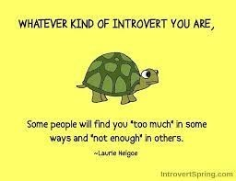
There was also another time in which I experienced marginalization. It was when I was in high school and had a free period. The teacher decided to play songs and asked the students to recommend a song to be played onto the projector for everyone to listen to and to while away the class time. When it got to my turn, I recommended BTS’S Fire since I am a kpop fan and that was my favorite song at the time. A kpop fan is a fan of Korean popular music. When the music video was played onto the projector, all I heard from the students was “ewww. What kind of music is this? We can’t even understand what they said.” At the time, when hearing that made me feel ashamed for liking kpop. After that class, I wondered why the class had that reaction and the comments made occurred to me, they did not like it because of the language being spoken and the fact that they did not understand it. It was very ironic because in high school, everyone was mandated to learn the Korean language as we needed to learn a language to take the LOTE (Languages Other Than English) regents as it was part of the requirements to graduate high school. So, I did not understand why they reacted that way to the music video. It still puzzles me to this day. But I cannot do anything about it when that is not what they are interested in. And according to Kelsey Benz’s prezi, “Everyone acts on their own self-interests" (Benz, slide 1). “Each action we take is done to benefit ourselves whether we realize it or not” (Benz, slide 2). Everyone does have their own interests, but it does not mean that other’s interests should be looked down upon.

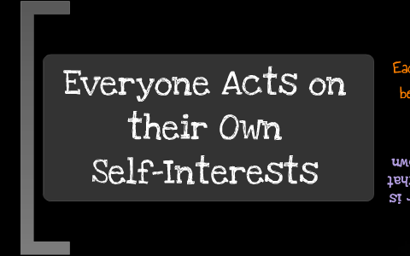
In conclusion, being an outsider as well as an introvert is not a dreadful thing because everyone is different and special in their own way. And everyone has their own special qualities which make them who they are, and introverted people are special people in their own way. So, treating introverted people badly because of who they are is considered bullying. And bullying is not good. Although marginalizing people is not good, it helps them to be better people. We are all special in our own ways and should not be marginalized because of that.

Works Cited
  - “Everyone Acts on Their Own Self-Interests.” Prezi.com, https://prezi.com/yjbdpgsu37li/everyone-acts-on-their-own-self-interests/.
  - Google Search, Google, https://www.google.com/search?q=introverts%2Bare%2Bnot%2Bbad%2Bpeople&tbm=isch&ved=2ahUKEwi_-MKyucjzAhW5gXIEHb9ADcwQ2-cCegQIABAA&oq=introverts%2Bare%2Bnot%2Bbad%2Bpeople&gs_lcp=CgNpbWcQAzoHCAAQsQMQQzoFCAAQgAQ6BAgAEEM6BwgjEO8DECc6CwgAEIAEELEDEIMBOggIABCABBCxAzoGCAAQBRAeOgYIABAIEB46BAgAEBhQ3dYBWMayAmCdtQJoAnAAeACAAX-IAbQPkgEEMjUuMpgBAKABAaoBC2d3cy13aXotaW1nwAEB&sclient=img&ei=U19nYf-CIrmDytMPv4G14Aw&bih=577&biw=1263&rlz=1C1CHBD_enUS894US894&hl=en#imgrc=pLiIGOus7pEonM.
  - “Is Being an Introvert Bad.” Times of India Blog, 13 July 2020, https://timesofindia.indiatimes.com/readersblog/wakeup-india/is-being-an-introvert-bad-23079/.

Reflection Paper
I had a tough time drafting my paper since I could not think of a time where I was clearly marginalized or witnessed marginalization. As a result, I wrote about the two times I could remember in which I was marginalized. It was hard also finding evidence to support my work since I did not have a specific theme.

